**[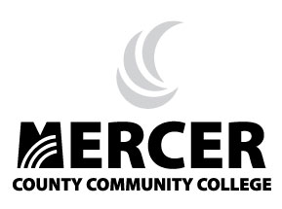](http://www.mccc.edu/)**

**DREAM Program**

**Developing Real Expectations for Achieving Mastery**

**Student Application**

**{ temporarily unavailable / we regret any inconvenience – RETURNING SOON }**